1.What is big data and what is pyspark ?
Big Data refers to datasets so massive, complex, or rapidly growing that they cannot be processed or stored by standard databases and traditional tools (like Excel or a single computer's RAM). It is primarily characterized by its Volume, Velocity, and Variety.
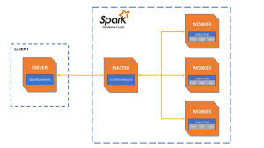
PySpark is the Python API for Apache Spark. It allows Python developers and data scientists to write Python code that leverages Spark's distributed computing engine to process, analyze, and build machine learning models on massive Big Data datasets across multiple machines.

2. Spark basic architecture
Apache Spark uses a master-slave architecture consisting of a single central coordinator called the Driver Program (the master) and multiple distributed computational workers called Executors (the slaves), which run inside Worker Nodes and are allocated by a Cluster Manager.
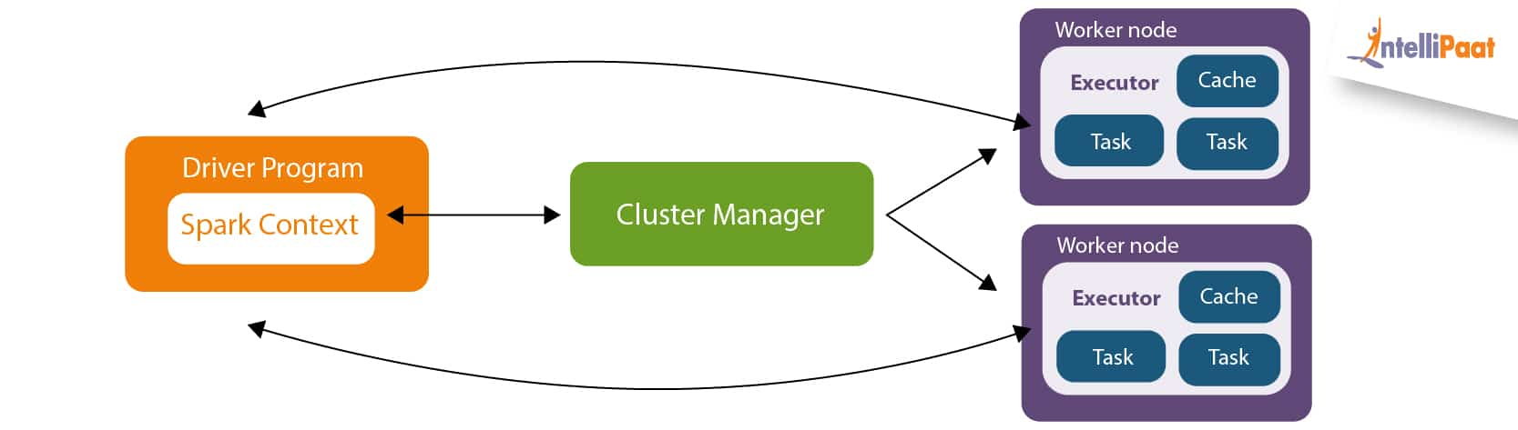
Central Coordination: The user application runs a primary script on the Master (Driver), converting code into computational stages.
Resource Request: The Master connects to a centralized manager to allocate hardware resources across the environment.
Distributed Execution: The data is broken into smaller chunks called partitions, and the tasks are sent to separate worker machines to run simultaneously.

3. Key Components: Cluster Manager, Sessions, Contexts, and Nodes
- Cluster Manager: An external service responsible for monitoring and allocating physical resources (CPU, RAM) across the cluster. Common variants include Hadoop YARN, and Spark’s native Standalone manager.
- SparkSession: Introduced in Spark 2.0, this is the unified entry point for programming with Spark. It consolidates previously separate contexts (like SQLContext and HiveContext) into a single interface for manipulating DataFrames and execution.
- SparkContext: The historical core heartbeat of a Spark application. It sets up internal services, creates a Directed Acyclic Graph (DAG) of execution, and establishes a direct network connection to the cluster manager to coordinate tasks.
- Driver Node: The machine where the main() function of your program runs. It compiles your code, schedules tasks via a Directed Acyclic Graph (DAG), and orchestrates the worker activities.
- Worker Node: The physical or virtual slave machines in the cluster assigned to do actual computation. They run persistent Java processes called Executors, which process individual tasks and cache partitions of data locally in RAM
4. Client Mode vs. Cluster Mode
When you submit a job to a cluster using spark-submit, you specify the deployment mode. The primary difference is where the Driver process physically executes.
Feature | Client Mode | Cluster Mode
Driver Location | Runs locally on the machine or gateway node where you submitted the script. | Runs inside a worker node or container allocated by the Cluster Manager.
Network Traffic | High. The local driver must constantly chat with executors on the remote cluster. | Low. The driver is physically close to the executors within the same data cluster.
Best Used For | Interactive debugging, REPL shells (PySpark terminal), and developing applications. | Production runs and automated pipeline scheduling.
Failure Vulnerability | If your local computer loses internet or shuts down, the entire job terminates abruptly. | Safe from local disconnects because the job runs entirely inside the remote cluster.

